**Resume Skill Match & Recommendation System – Design & Workflow Document**

# **1. Overview**

This document outlines the design and workflow for the Resume Skill Match and Recommendation System. The system automates the extraction and evaluation of technical skills and experience from candidate resumes to generate fit scores and hiring recommendations based on a provided job description.

# **2. Problem Statement**

Recruiters often spend significant time manually parsing resumes to assess candidate fit. This process is not only time-consuming but also error-prone. Our solution streamlines this by using LLMs to extract relevant data from resumes and evaluate against job criteria.

# **3. Key Goals / Objectives**

* Automatically extract technical skills and experience from resumes.
* Match candidate qualifications with job description.
* Provide actionable fit scores and hiring insights.
* Support bulk resume uploads and evaluation.
* Enable HR to download evaluation reports in CSV or Excel formats.

# **4. Product Workflow**

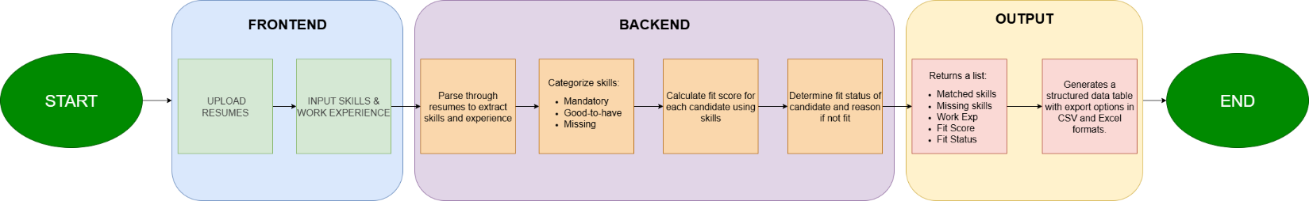

# **5. Detailed Component Breakdown**

## **5.1 Frontend – Streamlit UI**

* Upload interface for multiple PDF resumes
* Text fields for job criteria input
* Evaluation trigger button and loading spinner
* Table view of results
* Download buttons for CSV and Excel

## **5.2 Backend- Langchain**

* PyPDFLoader for resume parsing
* Ollama Client for skill & experience extraction using LLaMA 2
* Regex and logic for cleaning and calculating experience
* Evaluation algorithm for calculating fit score
* Pandas for result tabulation and download generation

# **6. Evaluation Logic**

The system uses a weighted scoring model to calculate candidate fit:

* 60% weight for mandatory skills match
* 40% weight for experience match
* Additional match on good-to-have skills (informative only)
* A candidate is marked 'Fit' if all mandatory skills match and experience meets the threshold.

# **7. Output Fields**

|  |  |  |  |  |  |
| --- | --- | --- | --- | --- | --- |
| Sl. No. | Resume Name | Candidate Name | Fit Score | Fit Status | Reason |

# **8. Current Limitations**

* LLM may occasionally misidentify skills or experience
* Skill extraction assumes consistent resume formatting
* Experience estimation based on textual cues, not employment history
* Only PDF files are currently supported

# **9. Future Enhancements**

* Add support for DOCX and other resume formats
* Use embeddings for fuzzy skill match
* Integrate with ATS (Applicant Tracking Systems)
* Enable scoring with weighted job requirements